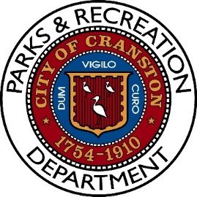
Notice of Meeting
Parks and Recreation Advisory Board Meeting
Tuesday, October 14th, 2025, 6:00PM
Pastore Youth Center
155 Gansett Avenue
Cranston, RI 02910

AGENDA

- Roll Call

- Spring and Summer Season Review

- Equipment Update

- Update on Ongoing Projects

  - What is completed
  - What is upcoming
  - Potential future projects

- Concerns about daily illegal garbage, What has been done and the results.

- Open Dialogue

- Adjourn

